
SYMBIOSIS CENTER OF CORPORATE AND PROFESSIONAL LEARNING
(A Unit of Symbiosis Skills and Professional University)

Name of Project
DASHBOARDS FOR CUSTOMER CHURN ANALYSIS

Candidate name:
SANJANA. V
Batch code: GESP-05
Location: BENGALORE

Guide Name
MR. VIDHEY TRIVEDI

Year
2026

Index

Sr. No | Content | Page
1 | EXECUTIVE SUMMARY | 3
2 | INTRODUCTION | 4-9
3 | LITERATURE REVIEW AND BACKGROUND STUDY | 9 - 10
4 | PROBLEM STATEMENT AND OBJECTIVES | 10
5 | METHODOLOGY AND  SYSTEM DESIGN | 12- 37
6 | IMPLIMENTATION AND EXECUTION | 37-41
7 | RESULT ANDD ANALYSIS | 41-44
8 | CONCLUSION | 44-45
9 | REFERENCES AND APPENDICES | 45-47

Executive Summary

Customer churn remains one of the most significant challenges for organizations, particularly in service driven industries such as telecommunications, banking, and subscription-based businesses. A high churn rate not only reduces revenue but also negatively impacts customer lifetime value (LTV) and long-term business growth. Since acquiring new customers is often more expensive than retaining existing ones, understanding and managing churn is critical for sustaining profitability.
This project focuses on the development of an Interactive Customer Churn Analysis Dashboard designed to provide a comprehensive, data-driven understanding of customer behavior and attrition patterns. Using business intelligence tools such as Tableau/Power BI, the dashboard transforms raw customer data into meaningful insights that support effective decision-making.
Customer churn is a major challenge in the industry, where customers frequently switch service providers due to pricing, service quality, or better offers. High churn rates lead to significant revenue loss and increased customer acquisition costs. Therefore, understanding customer behavior and identifying churn patterns is critical for companies to maintain competitiveness and profitability.
This project focuses on developing an interactive Telecom Customer Retention Intelligence Dashboard that helps analyse customer churn and supports data-driven decision-making. The system uses telecom customer data such as call usage, data consumption, subscription plans, contract types, billing details, and customer tenure to identify patterns associated with customer attrition.
The dashboard tracks key performance indicators including total customers, churn rate, retention rate, average revenue per user (ARPU), and revenue at risk. It also segments customers based on plan type, usage behaviour, payment methods, and tenure to highlight high-risk groups. By analysing churn drivers such as high monthly charges, low usage, poor service experience, and short-term contracts, the system provides meaningful business insights.
Additionally, the dashboard includes a decision-support component that enables telecom companies to take proactive retention actions such as offering personalized plans, discounts, and improved customer service. The interactive visualizations allow stakeholders to explore trends, monitor churn performance, and identify opportunities for improvement.
The dashboard enables to proactively manage customer churn, optimize retention strategies, and strengthen long-term profitability through actionable insights and data-driven decisions.
Overall, this project demonstrates how telecom companies can leverage business intelligence tools to transform raw customer data into actionable insights, reduce churn, improve customer satisfaction, and enhance long-term business growth.

Introduction
In today’s highly competitive industry, retaining existing customers has become as important as acquiring new ones. Customer churn represents a major challenge for telecom service providers, as it refers to customers discontinuing their services, switching to competitors, or opting for alternative service plans. With the availability of multiple telecom operators offering similar pricing, data packages, and service benefits, customers can easily migrate, making churn a critical concern for business growth and profitability.
High churn rates have a direct impact on revenue, customer lifetime value, and brand loyalty. Therefore, analyzing and managing churn is essential for telecom companies to sustain long-term success. Understanding customer behavior, usage patterns, and service experiences plays a key role in identifying why customers leave and what actions can be taken to retain them. Ignoring churn analysis can result in increased revenue loss and reduced competitive advantage in the market.
A Customer Churn Analysis Dashboard is a powerful business intelligence tool designed to monitor, measure, and analyze customer churn using interactive visualizations. Instead of relying on manual reports or raw datasets, stakeholders can access a centralized dashboard that provides a comprehensive overview of key churn metrics, customer trends, and risk indicators. Through the use of charts, graphs, and filters, the dashboard enables business users and analysts to quickly identify patterns and take timely actions.
Churn in the telecom companies is influenced by various factors such as network quality, pricing plans, data usage, customer service experience, billing issues, and customer tenure. By segmenting customers based on these attributes, organizations can identify high-risk groups such as low-usage customers, customers with high monthly charges, short-term subscribers, or those frequently contacting customer support. This segmentation helps in understanding which customers are more likely to churn and why.
This project focuses on developing an interactive Telecom Customer Retention Intelligence Dashboard that enables organizations to analyze churn behavior in a structured and data-driven manner. The dashboard supports decision-makers in identifying key churn drivers, monitoring performance metrics, and implementing targeted retention strategies. By leveraging actionable insights, telecom companies can improve customer satisfaction, reduce churn, and achieve sustainable business growth.

Significance of the Project
The Telecom Customer Retention Intelligence Dashboard plays a vital role in helping telecom organizations understand, manage, and reduce customer churn in a highly competitive market. The significance of this project lies in its ability to transform raw telecom data into meaningful insights that directly support business growth and customer retention strategies.
• Early Identification of Customer Churn
The project enables telecom companies to identify early warning signals of customer churn by analyzing usage patterns such as reduced data consumption, fewer call activities, or increased service complaints. This helps organizations take preventive actions before customers decide to switch to competitors.
• Enhances Customer Retention Strategies
By providing insights into customer behavior and preferences, the dashboard supports telecom companies in designing effective retention strategies such as personalized data plans, special offers, and loyalty programs, ensuring customers stay engaged for a longer duration.
• Supports Data-Driven Decision Making
The dashboard presents key performance indicators such as churn rate, retention rate, and average revenue per user (ARPU) in a clear and interactive format. This allows management to make quick and informed business decisions without relying on manual reports.
• Identifies High-Risk Customer Segments
The system categorizes customers based on their risk levels using factors like low usage, high billing amounts, and short tenure. This helps telecom providers focus on customers who are more likely to churn and take targeted actions.
• Analyzes Key Churn Drivers in Telecom
The project helps identify the main reasons behind customer churn, such as high monthly charges, poor network quality, limited data benefits, and frequent service issues. Understanding these drivers allows companies to improve their services and reduce customer dissatisfaction.
• Minimizes Revenue Loss
By calculating revenue at risk and identifying high-value customers who are likely to churn, the dashboard helps telecom companies protect their revenue and prioritize retention efforts where it matters most.
• Improves Customer Experience
The insights generated from the dashboard help organizations understand customer pain points such as service interruptions or billing issues. This enables telecom providers to enhance service quality and deliver a better customer experience.
• Enables Effective Customer Segmentation
The dashboard segments customers based on attributes such as plan type (prepaid/postpaid), data usage, tenure, and geographic location. This segmentation helps in understanding different customer groups and tailoring strategies accordingly.
• Automates Reporting and Saves Time
The system replaces traditional manual reporting methods with automated dashboards, reducing time and effort required for data analysis and enabling faster access to insights.
• Supports Strategic Business Planning
The project provides valuable insights that assist telecom companies in planning long-term strategies such as pricing optimization, service improvements, promotional campaigns, and customer engagement initiatives.
• Improves Operational Efficiency
By providing a centralized platform for monitoring customer behavior and churn metrics, the dashboard helps different teams such as marketing, customer support, and management work more efficiently and collaboratively.
• Provides Competitive Advantage
With better understanding of customer behavior and proactive churn management, telecom companies can stay ahead of competitors by offering better services and retaining more customers.
  - Project Introduction
The Customer Churn Analysis Dashboard project focuses on developing an interactive and data-driven solution to understand customer attrition in the telecom industry. With increasing competition among telecom service providers, customers have multiple options to switch between networks based on pricing, service quality, and data benefits. This makes customer churn a significant business challenge that directly impacts revenue, customer lifetime value, and overall profitability.
The project involves collecting and analyzing customer data that includes demographic details, service usage patterns, subscription plans, billing information, and customer interaction history. The collected data is processed through data cleaning, transformation, and analysis to identify meaningful patterns and trends associated with customer churn.
The main objective of this project is to design a user-friendly dashboard that provides a comprehensive view of key churn-related metrics such as churn rate, retention rate, average revenue per user and revenue at risk. Through visualizations such as charts, graphs, and filters, the dashboard helps stakeholders quickly identify high-risk customers and understand the factors and implementing targeted retention strategies.
The project is designed to support business users, analysts, and decision-makers by converting raw data into actionable insights. By leveraging business intelligence tools like Power BI or Tableau, the dashboard enhances decision-making capabilities and enables organizations to monitor customer behavior in real time.
Overall, this project demonstrates how a structured approach to data analysis and visualization can help companies reduce customer churn, improve customer satisfaction, and achieve sustainable business growth through informed, data-driven decisions.
  - Project Background
Customer churn has become a major concern for organizations across various industries such as banking, telecom, insurance, e-commerce, and subscription-based services. It refers to the loss of customers who discontinue using a company’s products or services over a period of time. High customer churn negatively impacts revenue, increases customer acquisition costs, and reduces overall business growth and sustainability.
In earlier times, businesses relied on traditional methods such as manual reporting and basic data analysis to monitor customer behavior. These approaches were often time-consuming, less accurate, and limited in providing real-time insights. As a result, organizations found it difficult to identify the reasons behind customer churn and were unable to take timely actions to prevent it. With the advancement of data analytics and business intelligence tools, organizations have shifted towards more efficient and automated solutions for analyzing customer behavior. Customer Churn Analysis Dashboards have emerged as a powerful tool that enables companies to monitor key metrics, visualize trends, and gain deeper insights into customer patterns.
This project is developed in response to the need for a structured, interactive, and user-friendly system that can help organizations understand customer churn, identify its key drivers, and support strategic actions to improve customer retention and business performance.
  - Scope of the Project
This project focuses on developing an interactive Customer Churn Analysis Dashboard that enables organizations to analyze customer behavior, identify churn patterns, and support effective retention strategies. The dashboard utilizes telecom customer data such as usage patterns, subscription details, billing information, and churn status to generate meaningful insights for business decision-making.
- Data Collection and Preparation
gathering telecom customer data from available datasets, which includes
- Customer demographics such as age, gender, location
- Contact details and Service usage data
- Billing information like monthly charges, total charges, payment methods
- Churn status (active customers or churned customers)
The collected data is then prepared for analysis through,
- Handling missing values or incomplete values
- Removing duplicate values and Converting data into appropriate formats
- Standardizing categorical variables.
- Churn Measurement and KPI Monitoring
The project includes tracking key churn-related metrics that help evaluate business performance.
- Total number of customers and churned customers
- Churn rate and retention rate
- Average Revenue Per User (ARPU)
- Revenue loss and revenue at risk
These KPIs provide a clear understanding of customer attrition and its financial impact.
- Customer Segmentation Analysis
The dashboard enables detailed segmentation of telecom customers to analyze churn behavior across different groups, including:
- Demographic segmentation (age groups, gender, location)
- Plan-based segmentation such as prepaid vs postpaid
- Usage-based segmentation like high data users, low usage customers, call frequency
It helps to get to know more about which customer segments are more prone to churn.
- Analysis of Churn Drivers
The project focuses on identifying the key factors influencing churn in telecom services
- High monthly billing or pricing issues
- Low usage of services (data or calls)
- Short customer tenure and Poor service experience.
These drivers allows businesses to take correct actions to reduce churn in the organization.
- Dashboard Development and Visualization
The final stage involves designing and developing an interactive dashboard using tools such as Power BI, Tableau, or Excel. The dashboard presents the information in the charts and graphs etc….
- KPI cards for quick performance overview
- Charts and graphs for trend and pattern analysis
- Filters and slicers for dynamic data exploration
  - Gaps Identified
• No Clear View of Customer Data
In many existing systems, customer data is scattered across different sources such as billing, usage, and service records. There is no single platform where all this information is combined and viewed together. Because of this, it becomes difficult to understand the complete picture of customer behaviour.
• Difficulty in Understanding Customer Behaviour
Traditional reports mainly show numbers but do not clearly explain how customers are using the service. It is hard to identify patterns like low usage, irregular activity, or changes in behaviour that lead to churn.
• Lack of Interactive Analysis
Most existing systems use static reports or Excel sheets where users cannot explore data freely. There are no filters or drill-down options, which limits deeper analysis and makes it harder to find useful insights.
• No Focus on High-Risk Customers
Organizations often do not have a clear way to identify which customers are more likely to leave. Without identifying high-risk customers, it becomes difficult to take early action to retain them.
• Limited Understanding of Why Customers Leave
Existing analysis does not clearly show the main reasons behind customer churn. Factors like high charges, low usage, or poor service are not properly highlighted, making it difficult to take corrective action.
• Manual and Time-Consuming Process
In many cases, data analysis is done manually, which takes a lot of time and effort. This delays decision-making and reduces efficiency.
• No Proper Support for Business Decisions
Reports only show data but do not help in deciding what actions to take. There is no clear connection between insights and business strategies like offers, service improvements, or customer engagement.
• Lack of Continuous Monitoring
Customer churn is not tracked regularly. Businesses only analyse churn after it happens, instead of monitoring it continuously to prevent it.

Problem Statement & Objectives

Problem Statement
In today’s business environment, many companies are facing problems with customer churn, where customers stop using their services or move to competitors. This creates a major issue because losing customers directly affects the company’s revenue and growth. Even though companies collect a lot of customer data, they are not always able to use it properly to understand why customers are leaving.
In most cases, the data is available but it is not presented in a clear or easy way. Many organizations still depend on basic reports or Excel sheets, which makes it difficult to identify patterns or trends in customer behavior. It also becomes hard to find out which customers are at risk and what factors are causing churn. Another problem is that there is no proper system to connect the data with business decisions. The reports may show numbers, but they do not clearly explain what actions should be taken to reduce churn. Because of this, companies are not able to take timely steps to retain their customers.
So, there is a need for a better solution in the form of an interactive dashboard that can organize the data, show clear insights, and help in understanding customer behavior. This will make it easier for businesses to identify churn patterns, focus on high-risk customers, and take the right actions to improve customer retention.
Objective of the Project
• Understand Customer Churn
The main objective of this project is to understand what customer churn is and how it is affecting the business. It focuses on identifying how many customers are leaving and how often it is happening.
• Track Churn Rate Over Time
The project aims to monitor churn rate over a period of time. This helps in knowing whether churn is increasing or decreasing and gives a clear picture of customer trends.
• Identify Different Customer Segments
Another objective is to divide customers into different groups based on their data, such as usage, tenure, or other factors. This makes it easier to understand which group is more likely to leave.
• Find Reasons Behind Churn
The project focuses on identifying the main reasons why customers leave. It looks at patterns like low usage, high charges, or other issues that may lead to churn.
• Identify High-Risk Customers
One important goal is to find customers who are more likely to churn. This helps businesses take early action and try to retain those customers.
• Create an Interactive Dashboard
The project aims to build a dashboard that shows all important data in one place. It uses charts and visuals so that users can easily understand the information without going through raw data.
• Make Analysis Simple and Fast
Instead of checking multiple reports, the dashboard helps users quickly analyze data and get insights in a simple way.
• Support Better Decision-Making
The final objective is to help businesses make better decisions. With clear insights, companies can take actions like improving services, offering discounts, or increasing customer engagement to reduce churn.

Methodology / System Design
Stakeholder Analysis
In this project, different stakeholders are involved at various stages, and each of them plays an important role in the success of the Customer Churn Analysis Dashboard. These stakeholders are identified based on their involvement, responsibilities, and the level of influence they have on the project.

1. Management / Business Owners
Management is one of the most important stakeholders in this project. They are responsible for making key business decisions based on the insights generated from the dashboard. They use the dashboard to monitor churn rate, customer retention, and revenue impact.
2. Business Analysts
Business analysts play a central role in understanding the business problem and translating it into data requirements. They analyse customer data, identify churn patterns, and define important KPIs such as churn rate, retention rate, and customer lifetime value.
3. IT / Development Team
The IT or development team is responsible for building and maintaining the dashboard system. They handle data integration from different sources such as CRM systems, billing systems, and support databases. They also ensure that the dashboard runs smoothly without technical issues.
4. Marketing Team
The marketing team uses the insights from the dashboard to design customer retention strategies such as offers, discounts, and engagement campaigns. They focus on targeting high-risk customers identified through churn analysis.
5. Customer Support Team
The customer support team interacts directly with customers and helps resolve their issues. They use the dashboard to identify dissatisfied or high-risk customers and take necessary actions to improve customer experience.
7. Customers (Indirect Stakeholders)
Customers are considered indirect stakeholders in this project. They do not directly interact with the dashboard, but they are the source of all the data used in the analysis. They benefit from improved services, better offers, and enhanced customer experience as a result of the insights generated.
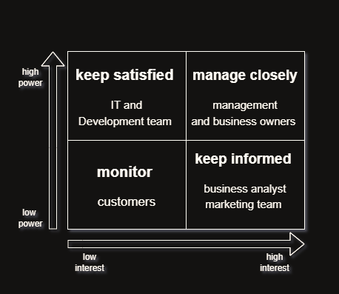
Power and Interest Matrix
Figure 1 - Power–Interest Matrix for Customer Churn Analysis
1. Management - (Manage Closely)
Management has high power because they make business decisions, approve strategies, and allocate resources for the project. They also have high interest because the dashboard helps them monitor churn rate, customer retention, and revenue impact. Since they have both high power and high interest, they must be managed closely by providing regular updates, reports, and insights from the dashboard.
2. IT and Development Team – (Keep Satisfied)
The IT team has high power because they are responsible for developing, implementing, and maintaining the dashboard system. They manage data connections, system performance, and technical infrastructure. Their interest is medium because they are more focused on technical implementation rather than business decisions. Therefore, they should be kept satisfied by providing clear requirements and proper communication.
3. Business Analysts – (Keep Informed)
Business analysts have high interest because they analyse churn data, identify trends, and prepare reports for management. However, they have low power because they do not make final decisions. Their role is to provide insights and recommendations. Therefore, they should be kept informed about project updates, data changes, and dashboard improvements.
4. Marketing Team – (Keep Informed)
The marketing team has high interest because they use the dashboard insights to create retention strategies, promotional campaigns, and customer engagement programs. Their power is low because they do not control the project decisions. Therefore, they should be kept informed about churn trends and customer segments.
5. Customer Support Team – (Keep Informed)
The customer support team has medium interest because they use the dashboard to identify unhappy customers and improve service quality. They have low power because they are not involved in project decision-making. Therefore, they should be kept informed about high-risk customers and service-related insights.
6. Customers – Low Power, Low Interest (Monitor)
Customers are indirect stakeholders. They have low power because they are not involved in project decisions and low interest in the dashboard system itself. However, they benefit from improved services and retention strategies. Therefore, customers should be monitored by tracking their behaviour and feedback.

STAKEHOLDER ANLYSIS
Stakeholders | Roles | Power level | Interest level | Risks
Management / Business Owners | Management uses the dashboard to monitor churn rate, retention rate, and revenue loss. They make strategic decisions and approve retention strategies based on dashboard insights. | high | High | risk of delay in decision-making or change in business requirements which may affect project timeline and scope.
Business Analysts | Business analysts analyse customer data, identify churn patterns, define KPIs, and prepare reports for management to support decision-making. | Medium | High | Risk of incorrect analysis or misunderstanding business requirements which may lead to wrong insights.
IT / Development Team | IT team is responsible for building, testing, and maintaining the dashboard. They also manage data integration and system performance. | medium | medium | Risk of technical issues such as system errors, integration problems, or dashboard performance issues.
Marketing Team | Marketing team uses dashboard insights to create customer retention campaigns, offers, and engagement strategies to reduce churn. | medium | High | Risk of wrong targeting or ineffective marketing strategies if dashboard data is not properly understood.
Customer Support Team | Customer support team uses the dashboard to identify dissatisfied customers and improve customer service and support experience. | low | medium | Risk of improper handling of customer complaints which may increase churn instead of reducing it.
Customers | Customers are the source of data and they benefit from improved services, offers, and better customer experience due to churn analysis. | low | medium | Risk of customer dissatisfaction, changing behaviour, or unexpected churn patterns which may affect analysis results.

Requirement Elicitation and Analysis
Requirement elicitation is the process of collecting requirements from stakeholders to understand what they expect from the system. In this project, the main purpose of requirement elicitation was to understand what type of information the business wants from the Customer Churn Analysis Dashboard and what features the dashboard should provide. The requirements were gathered by understanding business problems, discussing with stakeholders such as management, business analysts, marketing team, and customer support team, and analyzing the existing system. The main focus was to identify what data is required, what KPIs need to be displayed, what kind of reports are required, and how the dashboard should help in decision-making.
Requirement elicitation helps in clearly understanding the project goals, user expectations, and system functionality before starting dashboard development. This process reduces confusion, avoids rework, and ensures that the final dashboard meets business needs.
Functional requirements
The following functional requirements were identified after discussing with stakeholders such as management, marketing team, business analysts, and customer support team. These requirements define what the dashboard should do and what information it should display to help the business understand and reduce customer churn.

- The dashboard should display the total number of customers.
- The dashboard should display the number of churned customers.
- The system should calculate and display the churn rate.
- The system should calculate and display the customer retention rate.
- The system should calculate and display the revenue loss due to customer churn.
- The dashboard should show customer segmentation based on age, gender, and location.
- The dashboard should show customer churn based on contract type.
- The dashboard should show customer churn based on tenure.
- The dashboard should show customer churn based on payment method.
- The dashboard should show churn trend over time such as monthly or yearly.
- The system should identify high-risk customers who are likely to churn.
- The dashboard should provide filters such as location, gender, and contract type to analyse data.
- The dashboard should allow users to generate reports.
- The system should allow data refresh to update the dashboard regularly.
- The dashboard should display information using charts and graphs for easy understanding.

Non Functional Requirements
The following non-functional requirements were identified to ensure that the dashboard works efficiently, is easy to use, and provides reliable and secure information to users. These requirements describe how the system should perform

- The dashboard should be easy to use and user-friendly so that business users can understand it easily.
- The dashboard should load quickly without taking too much time.
- The system should provide accurate and reliable data.
- The dashboard should be available whenever required by users.
- The system should be able to handle large amounts of customer data.
- The dashboard should be reliable and should not crash or stop working.
- The system should keep customer data secure and maintain data privacy.
- The dashboard should allow multiple users to access it at the same time.
- The dashboard should be easy to navigate with proper layout and design.
- The system should allow users to download reports in PDF or Excel format.
- The dashboard data should be updated regularly.
- The system should work properly on devices like laptops and desktops.

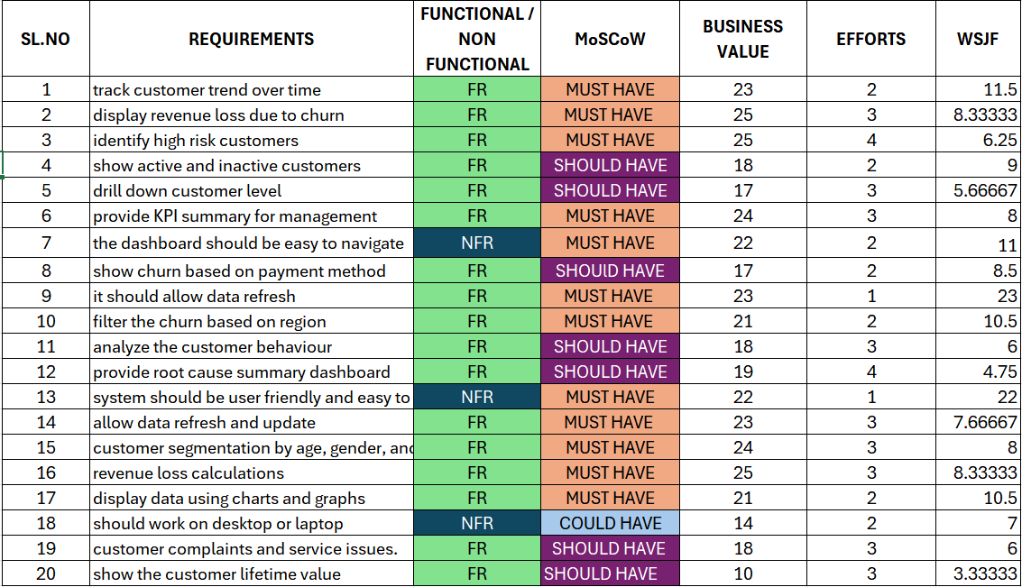
Picture showing requirement and prioritizing it using MoSCoW

Agile Project Management Methodology
Introduction to Scrum Methodology using JIRA
Agile methodology is a project management approach that focuses on developing a project in small and manageable phases. Agile methodology emphasizes flexibility, continuous improvement, and regular feedback. Instead of completing the entire project at once, Agile divides the project into smaller parts called iterations or sprints. Each sprint includes a set of tasks that must be completed within a specific period of time. Agile helps in managing changing requirements, improving project quality, and delivering the project in a structured and organized way.
In this project, Agile methodology was used to manage the development of the Customer Churn Analysis Dashboard. The project requirements were divided into smaller tasks, and each task was completed step by step. Agile methodology helped in better requirement management, task planning, and project tracking. It also helped in completing the project in a systematic and organized manner.
Scrum is one of the most commonly used Agile methodologies for project management. Scrum divides the project into small time periods called sprints. Each sprint contains a set of tasks that need to be completed within a specific time frame. Scrum includes three main roles: Product Owner, Scrum Master, and Development Team. The Product Owner is responsible for defining the project requirements and prioritizing the tasks. The Scrum Master is responsible for managing the Scrum process and ensuring that the team follows Agile practices. The Development Team is responsible for completing the tasks and developing the system.
In this project, Scrum methodology was used to manage the development of the Customer Churn Analysis Dashboard using Jira software. Jira is a project management tool used to manage Agile projects, track tasks, and monitor project progress.
The product backlog is a list of all the project requirements and tasks that need to be completed. The product backlog includes all user stories such as customer segmentation, churn analysis, revenue loss calculation, KPI dashboard, drill-down to customer level, data refresh, churn by payment method, customer behaviour analysis, root cause analysis, and customer lifetime value. The product backlog helps in organizing and prioritizing project requirements. The backlog items are arranged based on priority so that important tasks are completed first. The product backlog is continuously updated throughout the project.
Epics are large tasks or modules in a project that can be divided into smaller tasks called user stories. In this project, the system requirements were divided into three main epics: Customer Churn Analysis and Risk Management, Dashboard and Reporting System, and System Usability and Performance. Each epic represents a major part of the system and contains multiple user stories related to that module. Dividing the project into epics helped in organizing the project work into different functional areas.
User stories describe the system requirements from the user’s perspective. User stories explain what the user wants from the system and why the feature is required. User stories are written in a simple format such as: “As a user, I want this feature so that I can achieve a specific goal.” In this project, user stories were created for requirements such as tracking customer trend over time, identifying high-risk customers, customer segmentation, KPI dashboard, data refresh, churn by payment method, customer behaviour analysis, root cause summary dashboard, and customer lifetime value.
Acceptance criteria define the conditions that must be satisfied for a user story to be considered complete. Acceptance criteria help in ensuring that the system works according to the requirements. Acceptance criteria also help in testing whether the system is functioning correctly or not. For example, in the customer segmentation user story, the acceptance criteria specify that the system should segment customers by age, gender, and location, and the segmentation should be displayed in charts and graphs.
Sprint planning is the process of selecting user stories from the product backlog and adding them to a sprint. Each sprint contains a set of tasks that must be completed within a specific time period. In this project, the user stories were divided into three sprints. Sprint 1 focused on customer churn analysis and risk identification. Sprint 2 focused on dashboard and reporting features. Sprint 3 focused on system usability and performance requirements. Sprint planning helped in organizing the project work and completing tasks step by step.
Sprint execution is the process of completing the tasks included in the sprint. During sprint execution, the tasks move through different stages such as To Do, In Progress, and Done. The sprint board in Jira helps in tracking the progress of tasks and ensures that the tasks are completed within the sprint. The team works on the tasks and updates the status regularly. Once the task is completed and acceptance criteria are satisfied, the task is moved to the Done stage.
The Jira board is used to track the progress of user stories and tasks. The board consists of different stages such as To Do, In Progress, and Done. Tasks move from To Do to In Progress and then to Done once the task is completed. The Jira board helps in visualizing the project progress and managing tasks effectively. It also helps in identifying pending tasks and completed tasks.
Using Agile methodology and Jira software provided several benefits in this project. It helped in organizing project tasks, managing requirements, tracking progress, and completing the project in a structured manner. Agile methodology also helped in dividing the project into smaller tasks and completing them step by step. Jira helped in managing epics, user stories, sprints, and task status effectively. Thus, Agile and Jira played an important role in managing the Customer Churn Analysis Dashboard project successfully.
Data and Process Model
In this Customer Churn Analysis project, data and process modelling played an important role in converting raw customer data into meaningful insights. The project started with collecting customer data, which includes details such as Customer ID, gender, tenure, contract type, monthly charges, total charges, payment method, internet service, and churn status. After collecting the data, it was cleaned by removing duplicates, handling missing values, and correcting data types to ensure accuracy. Once the data was prepared, it was structured properly using data modelling techniques. A relational data model was created where different data fields were connected using Customer ID as a common key, which helped in organizing the data and making analysis easier. After building the data model, important, calculated metrics such as churn rate, retention rate, total customers, churned customers, revenue loss, and customer lifetime value were created to measure business performance. The next step was transforming the data into visual insights by developing an interactive dashboard in Tableau/Power BI, which includes charts like churn by contract type, churn by tenure, churn by payment method, and churn trends over time. Through this process, key patterns were identified, such as higher churn among customers with short-term contracts, low tenure, and higher monthly charges. Based on these insights, business recommendations like offering discounts, improving customer service, and introducing loyalty programs were suggested to reduce churn. Overall, data and process modelling helped in organizing the data, analyzing customer behaviour, and supporting data-driven decision-making to improve customer retention and business growth.

Data Sources
The data used in this Customer Churn Analysis project was collected from a customer data set. The data set contains customer demographic details, service usage information, account information, billing details, and churn status. Important fields in the data set include Customer ID, gender, senior citizen status, tenure, contract type, monthly charges, total charges, payment method, internet service type, and churn status. This data was used to analyse customer behaviour and identify the major factors contributing to customer churn.

Data Cleaning
After collecting the data, data cleaning was performed to ensure accuracy and consistency. The data cleaning process included removing duplicate records, handling missing values, correcting incorrect data entries, and converting data into appropriate formats. For example, blank values in total charges were handled, data types were corrected for numerical fields such as monthly charges and tenure, and categorical fields such as contract type and payment method were standardized. This step helped in improving data quality and ensured that the analysis results were accurate.

Data Transformation
Data transformation was performed to create new calculated columns and measures required for analysis. Several important business metrics were created during this step, such as churn rate, retention rate, revenue loss, total customers, churned customers, and customer lifetime value. Customer segmentation was also created to classify customers into high-risk, medium-risk, and low-risk categories based on tenure, monthly charges, and contract type. This transformation helped in analyzing the data more effectively and supported better visualization in the dashboard.

KPI Definition
Key Performance Indicators (KPI.s) were defined to measure customer churn and business performance. The main kpi used in this project are,
- Total Customers – Total number of customers in the data set
- Churned Customers – Number of customers who stopped using the service
- Churn Rate – Percentage of customers who churned
- Retention Rate – Percentage of customers who stayed with the company
- Revenue Loss – Estimated revenue lost due to churned customers
- Customer Lifetime Value (LTV) – Estimated revenue generated from a customer during their relationship with the company
These KPI’s help businesses understand the impact of churn on revenue and customer retention.

Agile Project Management using Jira

In this project, Jira software was used to manage the project using Agile Scrum methodology. The project requirements were first identified and then converted into user stories. These user stories represent the system functionality from the user’s perspective.
The user stories were created and added to the product backlog in Jira. Each user story includes a description and acceptance criteria. The description explains what the user wants from the system and why the feature is required. The acceptance criteria define the conditions that must be satisfied for the user story to be considered completed.

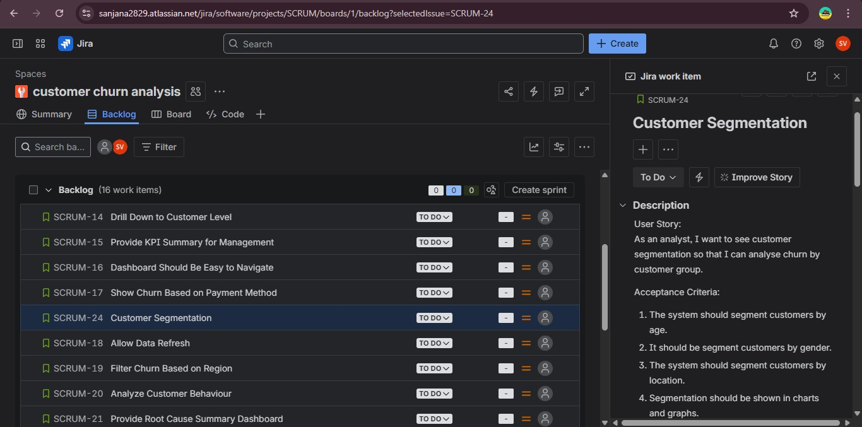
Screenshot of JIRA creating story , epics and task

The user stories created for this project include customer segmentation, churn analysis, revenue loss calculation, KPI dashboard, drill-down to customer level, data refresh, churn by payment method, customer behavior analysis, root cause analysis, and customer lifetime value. These user stories were linked to their respective epics such as Customer Churn Analysis, Dashboard and Reporting System, and System Usability and Performance.
All the user stories were managed in the Jira backlog. The backlog contains the list of all tasks that need to be completed in the project. The user stories were then moved to different stages such as To Do, In Progress, and Done based on the project progress.
Acceptance criteria were defined for each user story to ensure that the system meets the business requirements. For example, in the customer segmentation user story, the acceptance criteria specify that the system should segment customers by age, gender, and location, and the segmentation should be displayed in charts and graphs.
Thus, Jira helped in organizing project tasks, tracking progress, managing requirements, and ensuring that all system functionalities was implemented properly. Using Jira made the project management process more structured and systematic

Sprint Planning and Execution using Jira

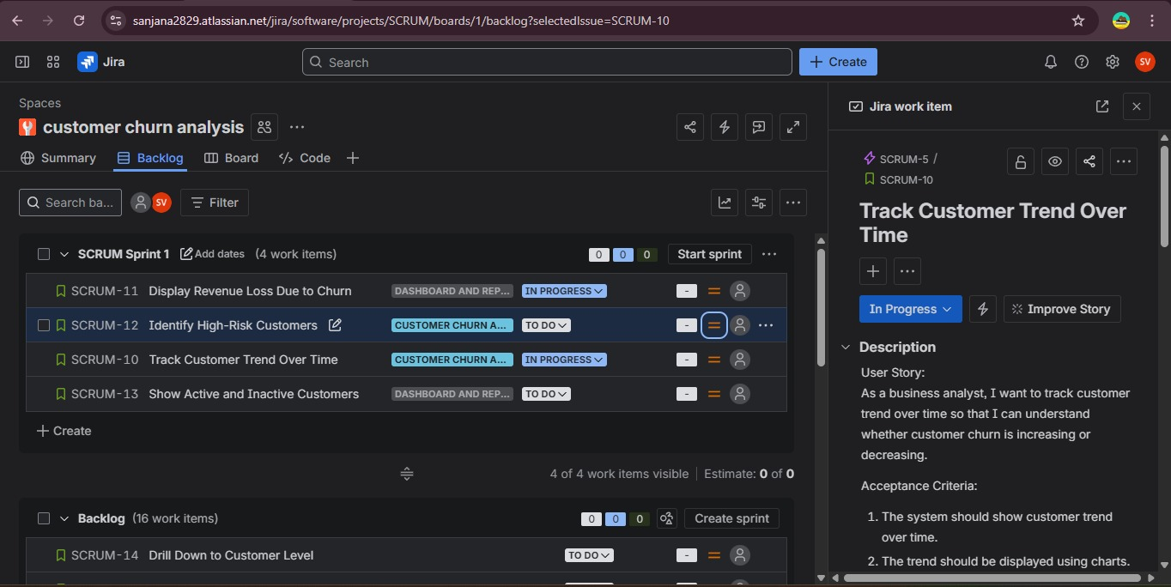 Screenshot showing Sprint Planning and Execution using Jira
Scrum methodology was used for project development and task management. After creating epics and user stories, the user stories were organized into sprints. A sprint is a fixed time period in which a set of user stories or tasks are completed.
In this project, the user stories were added to Sprint 1 based on priority. High priority tasks such as tracking customer trend over time, identifying high-risk customers, displaying revenue loss due to churn, and showing active and inactive customers were included in the first sprint.
Each user story in the sprint was assigned a status such as To Do, In Progress, and Done. The To Do status indicates that the task has not yet started, In Progress indicates that the task is currently being worked on, and Done indicates that the task has been completed.
The sprint board in Jira helps to track the progress of tasks and ensures that the project work is completed in a systematic and organized manner. It also helps in identifying which tasks are pending and which tasks are completed.
For each user story, acceptance criteria were defined to ensure that the task is completed according to the requirements. Once the acceptance criteria are satisfied, the task is marked as Done.
Thus, using sprints in Jira helped in planning the project work, tracking progress, managing tasks, and completing the project in an organized manner using Agile Scrum methodology.

Data Modelling
Data modelling is the process of organizing data into a structured format so that it can be used for analysis and dashboard creation. In this project, a relational data model was used where different data fields were connected using a common column called Customer ID, which acts as a primary key. The customer table contains customer demographic information and churn status, and it is connected with service-related data, billing data, and contract information. By creating relationships between tables using Customer ID, the data could be analysed from multiple perspectives such as churn by contract type, churn by payment method, churn by tenure, and churn by monthly charges. The data model made the dashboard interactive and helped in creating accurate analysis.

Process Modelling / Methodology
Process modelling explains the step-by-step procedure followed in this project. The project started with data collection from the customer churn data set. The next step was data cleaning to remove errors and missing values. After cleaning, data transformation was performed to create important kpi’s and calculated fields. Then data modelling was done by creating relationships between tables using Customer ID. After that, an interactive dashboard was developed using Tableau/Power BI to visualize churn trends and customer behaviour. The dashboard includes KPI cards, churn by contract type, churn by tenure, churn by payment method, churn by internet service, and churn trend over time. Finally, insights were generated from the dashboard, and business recommendations were provided to reduce customer churn and improve customer retention.
AS IS DIAGRAM
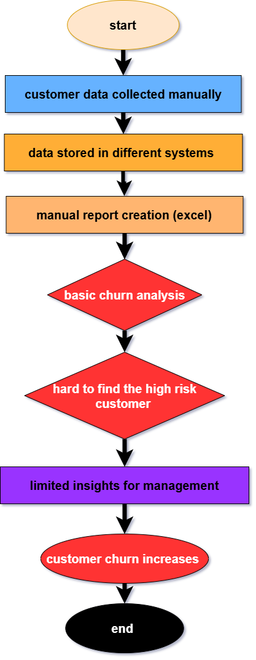
As is diagram explanation
The above diagram represents the current or existing process used by organizations to analyse customer churn. This process is mostly manual and not very efficient for identifying customer churn and taking preventive actions.
The process starts with customer data collection, where customer data is collected manually from different sources such as CRM systems, billing systems, and service databases. Since the data is collected from multiple sources, the data is usually stored in different systems and files, which makes it difficult to manage and analyse the data efficiently.
After data collection, the next step is manual report creation, which is usually done using Excel or other spreadsheet tools. In this step, employees manually prepare reports and calculate basic metrics related to customers. This process takes a lot of time and effort and may also lead to human errors.
Once the reports are created, the organization performs basic churn analysis. This analysis is limited and does not provide detailed insights about customer behaviour, high-risk customers, or the main reasons for churn. The analysis is mostly based on historical data and does not provide predictive insights.
Due to the lack of proper tools and systems, it becomes difficult to identify high-risk customers. The organization cannot easily identify which customers are likely to leave the service, and therefore preventive actions cannot be taken at the right time.
Because of this, the management receives limited insights and reports, which makes decision-making difficult. Management cannot clearly understand churn trends, revenue loss, or customer behaviour patterns.
As a result of all these limitations, the organization is not able to take proactive actions, and therefore customer churn increases over time, which leads to revenue loss and reduced customer retention.
This existing system shows the need for a better system that can automatically analyse customer data, identify high-risk customers, and provide dashboards and insights for better decision-making. This leads to the development of the proposed Customer Churn Analysis Dashboard System.
TO - BE DIAGRAM OR PROCESS FOLW DIAGRAM

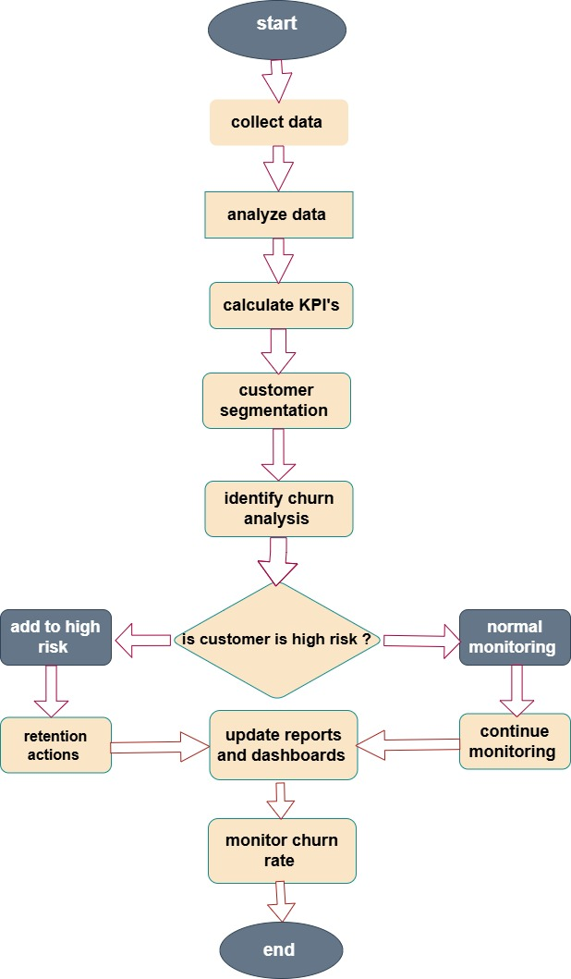
To be diagram explanation
The process flow diagram represents the step-by-step workflow of the Customer Churn Analysis System. This diagram explains how customer data is collected, analysed, and used to identify customers who are at risk of churning, and how the organization takes actions to reduce customer churn.
The process starts with data collection, where customer data is collected from the CRM system or company database. This data includes customer demographic details, service usage information, contract details, payment method, monthly charges, total charges, and churn status.
After collecting the data, the next step is to analyse the data. In this step, the data is examined to understand customer behaviour, service usage patterns, and customer tenure. This helps in understanding customer activity and identifying patterns related to customer churn.
The next step is to calculate Key Performance Indicators (KPIs). These KPIs include churn rate, retention rate, total customers, churned customers, revenue, and revenue loss. These KPIs help the organization measure business performance and understand the impact of churn on the business.
After KPI calculation, the next step is customer segmentation. In this step, customers are divided into different groups such as high-risk customers, medium-risk customers, and low-risk customers based on factors such as tenure, monthly charges, contract type, and service usage.
The next step is churn analysis, where customer data is analysed to identify customers who are likely to leave the service. Based on this analysis, a decision is made to determine whether the customer is a high-risk customer or not.
If the customer is identified as a high-risk customer, the customer is added to the high-risk category, and retention actions are taken. These retention actions may include offering discounts, providing special offers, improving customer service, or contacting the customer to resolve issues.
If the customer is not a high-risk customer, the customer is placed under normal monitoring, where the company continues to monitor the customer’s activity and service usage.
After this, the system updates the reports and dashboards to reflect the latest churn data and customer risk status. The organization then monitors the churn rate regularly to track whether churn is increasing or decreasing.
Finally, the process ends after monitoring the churn rate and evaluating the effectiveness of retention strategies. This process is continuous and helps the organization reduce customer churn and improve customer retention.

Gap Analysis

Existing System (As-Is) | Proposed System (To-Be) | Gap Identified
Customer data stored in multiple systems | Centralized dashboard for churn analysis | No centralized monitoring system
Manual data analysis using Excel | Automated dashboard using Power BI/Tableau | Time-consuming manual analysis
Static reports | Interactive dashboards and visual reports | No interactive visualization
No proper churn tracking | Churn rate and retention rate tracking | No churn monitoring system
Difficult to identify high-risk customers | High-risk customer identification | No customer risk segmentation
No KPI tracking | KPI dashboard (Churn Rate, Retention Rate, LTV, Revenue Loss) | No performance measurement
Slow decision-making | Real-time dashboard for decision-making | Delay in decision-making
No proper retention strategy | Retention campaign planning | No churn prevention strategy
Revenue loss not calculated | Revenue loss due to churn calculated | No revenue impact analysis
No customer segmentation | Customer segmentation based on tenure, charges, contract | No customer segmentation

RISK ANALYSIS
Risk Description | Impact | Likelihood | Mitigation Strategy | Owner
Poor Data Quality | Incorrect insights and wrong KPI values | Medium | Perform data cleaning, validation, and preprocessing before dashboard development | Data Analyst
Data Integration Issues | Data may not load properly into dashboard | Medium | Verify data sources, use proper data import methods, and perform integration testing | Data Team
Incorrect KPI Calculation | Wrong business decisions | Medium | Validate KPI formulas and cross-check calculations with sample data | Business Analyst
Dashboard Performance Issues | Slow dashboard loading and poor user experience | Low | Optimize data model, reduce unnecessary visuals, and use efficient queries | Dashboard Developer
Requirement Changes | Delay in dashboard development | Medium | Conduct regular stakeholder meetings and follow change management process | Business Analyst
User Adoption Risk | Users may not use the dashboard effectively | Medium | Provide user training and create user manuals | Management
Data Security Risk | Unauthorized access to customer data | Low | Implement role-based access control and secure data access | IT Team
Project Timeline Delay | Delay in project completion | Medium | Proper project planning and task tracking using JIRA | Project Manager
Incorrect Customer Segmentation | High-risk customers may not be identified correctly | Medium | Validate segmentation logic and test with sample data | Business Analyst
Dashboard/Report Errors | Incorrect reports and insights | Low | Perform dashboard testing and validation before deployment | Testing Team

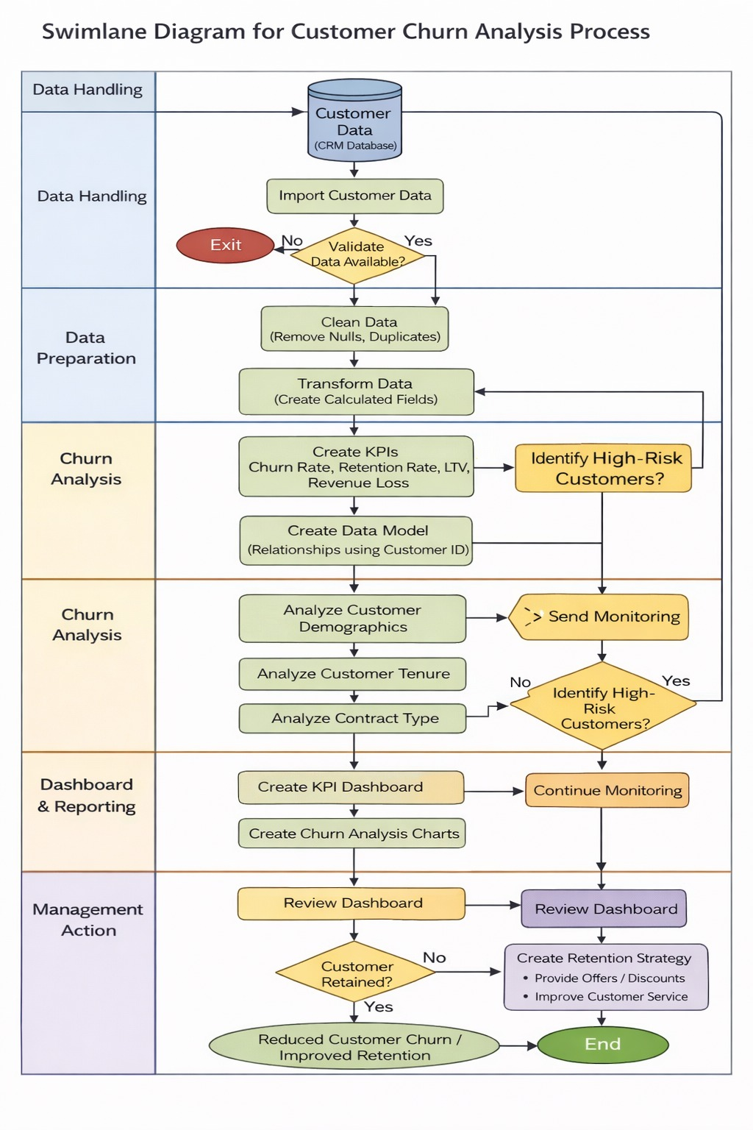
The Swim Lane Diagram represents the work flow involved in developing and using the Customer Churn Analysis Dashboard. The diagram shows the responsibilities of different teams such as Data Handling, Data Preparation, Churn Analysis, Dashboard & Reporting, and Management.
The process begins in the Data Handling stage, where customer data is collected from the CRM database and imported into the system. The data is then validated to ensure that the required data is available for analysis.
In the Data Preparation stage, the collected data is cleaned and transformed. Data cleaning involves removing null values, removing duplicate records, and correcting errors in the data set. Data transformation involves creating calculated fields and preparing the data for analysis in tools such as Power BI or Tableau.
In the Churn Analysis stage, Key Performance Indicators (KPIs) such as churn rate, retention rate, revenue loss, and customer lifetime value are calculated. Customer data is then analysed based on demographics, tenure, and contract type to identify patterns and high-risk customers.
In the Dashboard & Reporting stage, KPI dashboards and churn analysis charts are created using data visualization tools. These dashboards display churn trends, customer segmentation, and revenue impact. The dashboards help in understanding customer behaviour and churn patterns.
In the Management stage, the dashboard is reviewed by management to make business decisions. Based on the dashboard insights, management creates retention strategies such as offering discounts, improving customer service, and contacting high-risk customers. The main objective of the dashboard is to reduce customer churn and improve customer retention.
This swim lane diagram shows how data is collected, prepared, analysed, and visualized in the form of dashboards to support business decision-making.
Data flow
The data flow in the Customer Churn Analysis System begins with collecting customer data from the CRM system and company database. The collected data includes customer demographic details, service usage information, contract type, payment method, monthly charges, total charges, and churn status. This data is the main input for the churn analysis system.
Once the data is collected, the next step is data cleaning and validation. In this step, duplicate records are removed, missing values are handled, and data types are corrected to ensure the data is accurate and consistent. This step is important because accurate data helps in generating correct insights and reports.
After cleaning the data, the data is transformed into a structured format suitable for analysis. In this step, calculated columns and measures are created, such as churn rate, retention rate, total customers, churned customers, revenue, revenue loss, and customer lifetime value. These metrics help in measuring business performance and understanding the impact of customer churn.
Once the data is transformed and KPIs are calculated, the system performs churn analysis. In this step, customer behaviour is analysed based on factors such as tenure, contract type, monthly charges, internet service, and payment method. This analysis helps in identifying patterns and understanding the main reasons for customer churn.
After churn analysis, customers are segmented into different categories such as high-risk customers, medium-risk customers, and low-risk customers. High-risk customers are those who are more likely to leave the service based on their behaviour and service usage.
The results of the churn analysis are then displayed in the form of dashboards and reports. These dashboards include KPI metrics, churn trends, customer segmentation, and revenue analysis. The dashboards help management understand customer behaviour and churn trends.
Based on the dashboard insights, the management, marketing team, and customer support team take necessary actions such as creating retention campaigns, offering discounts, improving customer service, and contacting high-risk customers. These actions help in reducing customer churn and improving customer retention.
This data flow process is continuous, and the dashboards are updated regularly to monitor churn rate, retention rate, and business performance. The entire system helps the organization move from manual analysis to a data-driven decision-making system
ER Diagram for Customer Churn Analysis System
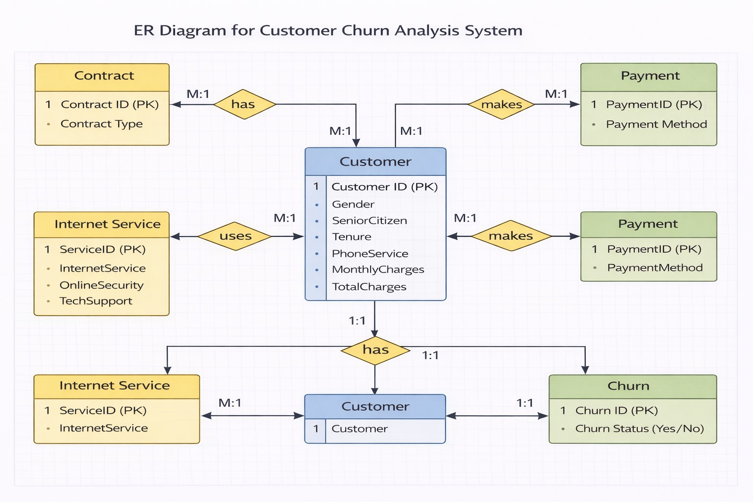
The Entity Relationship (ER) Diagram represents the database structure used in the Customer Churn Analysis System. The main purpose of this ER diagram is to show the entities involved in the system, their attributes, and the relationships between them. This helps in understanding how customer data is stored, connected, and used for churn analysis.
In this system, the Customer entity is the central entity. It contains the basic information about the customer such as Customer ID, gender, senior citizen status, tenure, phone service, monthly charges, and total charges. The Customer ID acts as the primary key, which uniquely identifies each customer in the system. All other entities are connected to the Customer entity.
The Contract entity contains information about the customer’s contract details. It includes attributes such as Contract ID and Contract Type (Month-to-Month, One Year, Two Year). Each customer has one contract type, but many customers can have the same contract type. Therefore, the relationship between Customer and Contract is many-to-one (M:1).
The Internet Service entity contains information about the services used by the customer, such as Internet Service type (DSL, Fiber, or No Internet), Online Security, and Tech Support. Each customer uses one type of internet service, but many customers can use the same service type. Therefore, the relationship between Customer and Internet Service is many-to-one (M:1).
The Payment entity contains payment-related information such as Payment ID and Payment Method (Credit Card, Bank Transfer, Mailed Check, etc.). Each customer uses one payment method, but many customers can use the same payment method. Therefore, the relationship between Customer and Payment is many-to-one (M:1).
The Churn entity contains the churn status of the customer, which indicates whether the customer has left the service or continues to use the service. It includes attributes such as Churn ID and Churn Status (Yes/No). Each customer has only one churn status, so the relationship between Customer and Churn is one-to-one (1:1).
Overall, the ER diagram shows that the Customer entity is connected to Contract, Internet Service, Payment, and Churn entities. These relationships help in organizing customer data and make it easier to analyse customer churn based on contract type, services used, payment method, and other customer-related information. This database structure helps in performing churn analysis and generating insights for business decision-making.
Use case diagram
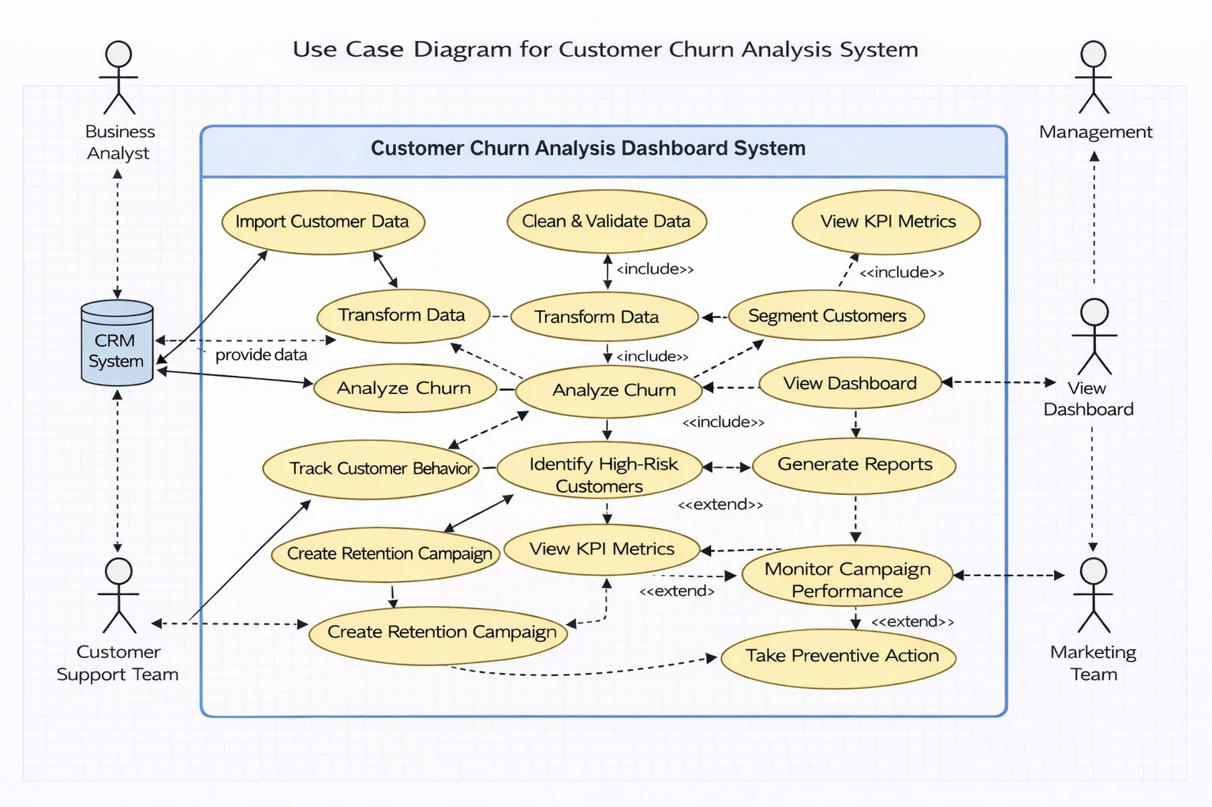

The Use Case Diagram represents the interaction between different users and the Customer Churn Analysis Dashboard System. This diagram shows how different users such as the Business Analyst, Management, Customer Support Team, Marketing Team, and CRM System interact with the system to perform churn analysis and reduce customer churn.
In this system, the process begins with the CRM System, which provides customer data to the system. The Business Analyst imports customer data into the system and performs data cleaning and validation to ensure the data is accurate and complete. After cleaning the data, the Business Analyst transforms the data and creates Key Performance Indicators (KPIs) such as churn rate, retention rate, revenue loss, and customer lifetime value.
Once the data is prepared, the Business Analyst performs churn analysis to understand customer behaviour and identify patterns related to customer churn. The system then performs customer segmentation and identifies high-risk customers based on factors such as tenure, contract type, monthly charges, internet service, and payment method. The system also tracks customer behaviour to monitor usage patterns and service usage.
The Management team uses the system to view dashboards and KPI metrics and to generate reports. These dashboards help management understand churn trends, customer behaviour, and revenue impact. Based on the dashboard insights and reports, management can make strategic decisions.
The Customer Support Team and Marketing Team use the system to create retention campaigns for high-risk customers. These campaigns may include offering discounts, providing special offers, improving customer service, or contacting customers directly. The marketing team also monitors campaign performance to evaluate whether the retention strategies are working.
If the retention campaign is successful, the customer continues using the service. If not, the system helps the organization take preventive actions to reduce churn in the future. This entire system helps the organization move from basic churn analysis to a data-driven churn management system.
Overall, the Use Case Diagram shows how customer data flows from the CRM system into the churn analysis system, how the Business Analyst analyses the data, how management views dashboards and reports, and how the support and marketing teams take actions to reduce customer churn. This diagram is directly connected with the process flow diagram, DFD, and ER diagram, as all diagrams represent the same system from different perspectives.
Phases of project development
1.Requirement Gathering and Problem Identification
The first phase of the project involved understanding the business problem and gathering requirements. The main problem identified was customer churn, which causes revenue loss and affects business growth. The objective of the project was to develop a Customer Churn Analysis Dashboard that helps in monitoring churn rate, identifying high-risk customers, and supporting management in decision-making. In this phase, the required KPIs such as churn rate, retention rate, total customers, churned customers, revenue, revenue loss, and customer lifetime value were identified.
2. Data Collection
In this phase, customer data was collected from the CRM system and company database. The dataset included customer demographic details, service usage information, contract type, payment method, tenure, monthly charges, total charges, and churn status. This data was used as the main input for the dashboard and churn analysis.
3. Data Cleaning and Preparation
In this phase, the collected data was cleaned and prepared for analysis. This included removing duplicate records, handling missing values, correcting data types, and ensuring data consistency. Data transformation was also performed by creating calculated columns and measures required for churn analysis and KPI calculation.
4. Data Analysis and Data Modelling
In this phase, the cleaned data was analysed to understand customer behaviour and churn patterns. Customer segmentation was performed to identify high-risk customers. A data model was created by establishing relationships between different data fields using Customer ID. KPIs such as churn rate, retention rate, revenue loss, and customer lifetime value were calculated in this phase.
5. Dashboard Design and Development
In this phase, the dashboard wireframe was created to design the layout of the dashboard. After designing the wireframe, the actual dashboard was developed using Power BI or Tableau. KPI cards, charts, filters, and interactive visualizations were created to analyse customer churn and display insights in a visual format.
6. Testing, Insights, and Reporting
In this phase, the dashboard was tested to ensure that all KPIs and charts were working correctly. The dashboard was validated to ensure data accuracy. Insights were generated from the dashboard to identify churn patterns and high-risk customer segments. The results were documented in the report.
7. Recommendations and Conclusion
In the final phase, business recommendations were provided based on the insights obtained from the dashboard. Recommendations such as retention strategies, customer engagement, service improvement, and loyalty programs were suggested to reduce customer churn. The project was then concluded by summarizing the overall findings and explaining how the dashboard helps in reducing churn and improving customer retention.

Implementation / Execution

TOOLS AND TECHNOLOGIES

Microsoft Excel (Data Preparation and Cleaning)
Microsoft Excel was used during the initial stage of the project for data preprocessing and preparation. The dataset was reviewed to understand its structure, remove duplicate records, handle missing values, verify data consistency, and perform basic data cleaning. Excel also helped in organizing the data before importing it into Power BI for further analysis, ensuring that the dataset was accurate and ready for visualization.
Microsoft Power BI (Data Visualisation and Dashboard Development )
Microsoft Power BI was used as the primary Business Intelligence and Data Visualization tool for this project. It was used to build the data model, create calculated columns and DAX measures, develop interactive KPI cards, and design six interconnected dashboards. Various visualizations such as bar charts, pie charts, donut charts, waterfall charts, scatter plots, treemaps, decomposition trees, key influencers, gauges, matrices, and slicers were created to analyse customer churn, revenue performance, customer segmentation, service usage, and high-risk customers. Power BI enabled stakeholders to interact with the dashboards dynamically and make data-driven business decisions.

IBM Telco Customer Churn Dataset (Kaggle)
The project used the IBM Telco Customer Churn Dataset, which was obtained from Kaggle. The dataset contains real-world telecommunications customer information, including customer demographics, subscription details, service usage, contract types, payment methods, billing information, tenure, monthly charges, total charges, and churn status. This dataset served as the primary data source for analysing customer behaviour, identifying churn patterns, measuring revenue impact, segmenting customers, and generating business insights. Its comprehensive structure made it suitable for developing an end-to-end Business Analysis and Data Analytics solution.
Dashboards for customer churn analysis

dashboard analysis and interpretations

6.1 Executive Overview & Key Metrics
The Executive Overview dashboard was developed to provide stakeholders with a complete summary of the customer churn situation through a single interactive view. It serves as the entry point of the dashboard solution by presenting key business metrics such as Total Customers, Active Customers, Churned Customers, Churn Rate, Retention Rate, and Revenue Loss. Along with these KPIs, the dashboard highlights customer distribution based on gender, contract type, internet service, and customer tenure.
The analysis revealed that the organization has a churn rate of 26.54%, indicating that more than one-fourth of the customers have discontinued their services. A significant revenue loss of approximately ₹2.86 million was also identified due to customer churn. Customers with Month-to-Month contracts and those using Fiber Optic internet services contributed the highest share of churn. The tenure analysis showed that customers were more likely to leave during the initial months of their subscription.
This dashboard enables management to monitor overall business performance quickly, identify key churn trends, and understand the financial impact of customer attrition. It provides a strong foundation for further analysis in the subsequent dashboards and supports faster, data-driven decision-making.

6.2 Service Analysis
The Service Analysis dashboard focuses on evaluating how different telecom services influence customer churn. It analyses customer subscriptions across Internet Service, Multiple Lines, Phone Service, Online Security, Tech Support, Streaming TV, Streaming Movies, and Payment Methods to identify the services that contribute most to customer attrition.
The analysis indicates that customers using Fiber Optic Internet Services experience the highest churn compared to DSL and customers without internet services. Customers who do not subscribe to Online Security and Tech Support services show a significantly higher tendency to churn, suggesting that value-added services improve customer retention. The dashboard also reveals that Electronic Check is the most commonly used payment method among churned customers, while Phone Service represents the largest customer base.
These insights help the organization understand customer service usage patterns and identify opportunities to enhance service quality, bundle additional services, and implement targeted retention strategies. By improving customer engagement through value-added services, the company can reduce churn and strengthen long-term customer relationships.

6.3 Customer Segmentation
The Customer Segmentation dashboard categorizes customers into meaningful business groups based on demographic characteristics, contract types, tenure, payment methods, and senior citizen status. The objective of this dashboard is to understand customer behaviour across different segments and identify which customer groups are more likely to churn.
The analysis shows that customers with Month-to-Month contracts represent the highest proportion of churn. The Key Influencers and Decomposition Tree visuals further indicate that contract type and payment method are among the strongest factors influencing customer churn. Senior Citizens also exhibit relatively higher churn compared to other customer groups. The dashboard highlights that customers with shorter tenure are more likely to leave, while long-term contract customers demonstrate stronger retention.
These findings allow the business to implement customer-specific retention strategies instead of adopting a single approach for all customers. Marketing teams can design personalized offers, loyalty programs, and engagement campaigns based on customer characteristics, ultimately improving customer satisfaction and reducing churn.

6.4 Revenue Analysis
The Revenue Analysis dashboard evaluates the financial impact of customer churn by analysing revenue performance across different customer groups, contract types, and payment methods. The dashboard includes key business metrics such as Total Revenue, Revenue Loss, ARPU, Average Customer Lifetime Value (CLTV), Revenue Risk Percentage, and Profitability Ratio.
The analysis identifies a total revenue of approximately ₹16.06 million, while revenue loss due to customer churn exceeds ₹2.86 million. Customers with Month-to-Month contracts contribute significantly to revenue loss because of their higher churn rates. The revenue distribution analysis also indicates that Electronic Check generates a large share of revenue transactions. The relationship between Monthly Charges and Customer Lifetime Value demonstrates that customers with higher lifetime value contribute greater long-term revenue, making customer retention financially important.
The Revenue Analysis dashboard enables management to evaluate financial risks associated with customer churn and prioritize strategies that maximize profitability. By reducing customer attrition and improving retention, the organization can protect future revenue and enhance long-term business growth.

6.5 High Risk Customer Analysis
The High Risk Customer Analysis dashboard identifies customers with the highest probability of churn by analysing churn scores, customer risk levels, monthly charges, customer lifetime value, internet services, and contract types. The dashboard enables proactive identification of customers who require immediate retention efforts.
The analysis identifies 1,869 high-risk customers with an estimated revenue risk exceeding ₹2.86 million. Customers categorized as High and Critical risk represent the largest portion of potential churn. The dashboard also reveals that customers using Fiber Optic services and Month-to-Month contracts are more likely to fall into high-risk categories. The Key Influencers visual confirms that contract type is one of the strongest factors influencing customer churn.
These insights enable customer service teams to prioritize retention campaigns for customers who are most likely to leave. Early identification of high-risk customers allows the organization to implement targeted interventions, improve customer satisfaction, and minimize future revenue loss.

6.6 Strategic Recommendations and Business Impact
The Strategic Recommendations and Business Impact dashboard converts analytical findings into practical business actions. Based on the insights generated throughout the project, this dashboard presents a phased implementation roadmap, executive summary, priority recommendations, expected revenue recovery, and customer retention objectives.
The recommendations are organized into four implementation phases ranging from immediate actions within three months to long-term initiatives extending beyond one year. Short-term recommendations focus on offering contract discounts, improving Tech Support services, and increasing customer awareness. Medium-term strategies include promoting Fiber service improvements and encouraging AutoPay adoption. Long-term recommendations emphasize customer loyalty programs, personalized engagement, predictive analytics, and AI-based churn prediction systems.
The dashboard estimates that implementing these recommendations can significantly improve customer retention while reducing future revenue loss. It provides management with a structured action plan that transforms analytical insights into measurable business outcomes, supporting sustainable growth and long-term customer loyalty.

Conclusion
This project provided me with an excellent opportunity to apply both Business Analysis and Data Analytics concepts to solve a real-world business problem. The project followed a complete end-to-end approach, starting with understanding the business problem, identifying stakeholders, gathering business requirements, and transforming those requirements into meaningful analytical solutions.
During the Business Analysis phase, I performed stakeholder analysis, requirement gathering, BRD preparation, MoSCoW prioritization, user story creation, functional and non-functional requirement analysis, gap analysis, risk analysis, and Agile Scrum project planning using Jira. These activities helped establish clear business objectives before beginning the analytical phase.
The Data Analytics phase involved working with the IBM Telco Customer Churn Dataset obtained from Kaggle. The dataset was cleaned, transformed, and prepared for analysis using Microsoft Excel and Power BI. DAX measures and calculated columns were created to calculate important business metrics such as Customer Churn Rate, Retention Rate, Revenue Loss, Customer Lifetime Value (CLTV), ARPU, and other key performance indicators.
Using these insights, I developed six interactive Power BI dashboards, namely Executive Overview, Service Analysis, Customer Segmentation, Revenue Analysis, High Risk Customer Analysis, and Strategic Recommendations & Business Impact. Each dashboard addressed a specific business objective and together provided a complete view of customer behaviour, service performance, financial impact, customer segmentation, churn risk, and strategic recommendations.
The analysis revealed that customer churn is mainly influenced by factors such as Month-to-Month contracts, Fiber Optic Internet Services, shorter customer tenure, and the absence of value-added services like Online Security and Tech Support. These insights helped identify high-risk customers, evaluate revenue loss, and recommend targeted retention strategies to improve customer satisfaction and long-term customer loyalty.
Overall, this project strengthened my skills in Business Analysis, Data Analytics, data visualization, dashboard design, DAX, requirement analysis, and business storytelling. It demonstrated how Business Analysis, Data Analytics, and Business Intelligence can be integrated to convert raw data into actionable business insights. This project has significantly improved my analytical thinking, problem-solving ability, and understanding of real-world business scenarios, preparing me for future roles as a Business Analyst and Data Analyst.

References
• Microsoft Corporation. (2024). Microsoft Power BI Documentation. Available at: https://learn.microsoft.com/en-us/power-bi/
• Microsoft Corporation. (2024). Microsoft Excel Documentation. Available at: https://support.microsoft.com/excel
• Atlassian. (2024). JIRA Software Documentation. Available at: https://www.atlassian.com/software/jira
• Han, J., Kamber, M., & Pei, J. (2011). Data Mining: Concepts and Techniques. Morgan Kaufmann Publishers.
• Turban, E., Sharda, R., & Delen, D. (2014). Business Intelligence and Analytics: Systems for Decision Support. Pearson Education.
• Online Resources on Customer Churn Analysis:
- https://www.kaggle.com/
- https://towardsdatascience.com/
- https://www.analyticsvidhya.com/
General Concepts of Customer Relationship Management (CRM) and Customer Retention Strategies from academic and online sources.
Data Visualization and Dashboard Design Principles from standard BI practices and online learning resources.

Appendices

Appendix A: Dataset Description
The project uses the IBM Telco Customer Churn Dataset obtained from Kaggle. The dataset contains customer demographic information, telecom service subscriptions, billing details, contract information, payment methods, tenure, and customer churn status. It was selected because it represents a real-world telecommunications business scenario and provides sufficient information to analyse customer behaviour, identify churn patterns, evaluate revenue impact, and support data-driven business decisions. The dataset served as the primary source for developing all dashboards and performing customer churn analysis.

Appendix B: Data Preparation and Cleaning Process
Before analysis, the dataset was carefully prepared to ensure data quality and consistency. The data cleaning process included removing duplicate records, handling missing values, verifying data types, correcting inconsistent entries, and organising the dataset into a structured format suitable for analysis. Additional calculated columns and DAX measures were created in Power BI to support KPI calculations and dashboard development. These preprocessing steps ensured that the final dataset was accurate, reliable, and ready for visualization.

Appendix C: Key Metrics and DAX Calculations
Several business KPIs were created to measure customer churn and business performance. The primary metrics include Customer Churn Rate, Retention Rate, Revenue Loss, Total Revenue, Average Revenue Per User (ARPU), Customer Lifetime Value (CLTV), Average Monthly Charges, Average Tenure, High-Risk Customers, Expected Revenue Recovery, and Profitability Ratio. These calculations were implemented using DAX measures and calculated columns in Microsoft Power BI to provide accurate and dynamic business insights across all dashboards.

Appendix D: Dashboard Components
The Power BI solution consists of six interactive dashboards, namely Executive Overview & Key Metrics, Service Analysis, Customer Segmentation, Revenue Analysis, High Risk Customer Analysis, and Strategic Recommendations & Business Impact. The dashboards include KPI cards, bar charts, column charts, donut charts, pie charts, line charts, waterfall charts, scatter plots, treemaps, decomposition trees, key influencer visuals, gauges, matrices, slicers, filters, and navigation buttons. These components provide an interactive and user-friendly experience for analysing customer churn from multiple business perspectives.

Appendix E: Tools and Technologies Used
The project was developed using Microsoft Excel for initial data preparation and preprocessing, Microsoft Power BI for data modelling, DAX calculations, dashboard development, and data visualization, and the IBM Telco Customer Churn Dataset obtained from Kaggle as the primary data source. Jira was used during the Business Analysis phase to manage Agile activities, user stories, sprint planning, and project task tracking.

Appendix F: Project Limitations
The analysis is based on the IBM Telco Customer Churn Dataset available on Kaggle and therefore represents a specific business scenario within the telecommunications industry. The dashboards analyse historical customer data and do not include real-time customer transactions or live business updates. External factors such as market competition, economic conditions, customer preferences, promotional campaigns, and competitor activities were beyond the scope of this project. Additionally, business recommendations are based on the available dataset and analytical findings.

Appendix G: Future Scope
The project can be further enhanced by integrating real-time telecom data sources to enable live dashboard reporting and continuous monitoring. Machine Learning models can be incorporated to improve churn prediction accuracy and identify future high-risk customers. Additional predictive analytics, forecasting models, customer sentiment analysis, and AI-driven recommendation systems can further strengthen decision-making. Future enhancements may also include automated alerts, cloud-based dashboard deployment, and integration with CRM systems to support proactive customer retention strategies.

Appendix H: Business Outcomes
The Customer Churn Analysis project successfully transformed raw telecom customer data into meaningful business insights through Business Analysis and Data Analytics techniques. The interactive dashboards enabled stakeholders to monitor customer churn, identify high-risk customers, evaluate revenue impact, analyse customer segments, and understand service usage patterns. Based on these insights, strategic recommendations were developed to improve customer retention, reduce revenue loss, enhance customer satisfaction, and support data-driven business decision-making. The project demonstrates how Business Intelligence solutions can assist organizations in achieving long-term business growth and operational efficiency.

